INTRODUCTION TO C
C is a
1.It is a high level / middle level programming language.
2.It is a compiler based programming language. 3.It is a procedure oriented programming language [ POP ]
4.It is a general purpose programming language.
What is a program?
Set of instructions is called program.
What is a software?
Set of programs is called software.
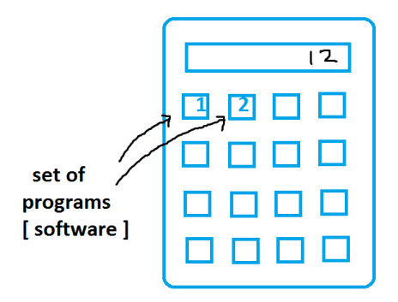Or
As per IT Industry software is a digitalized and automated process.
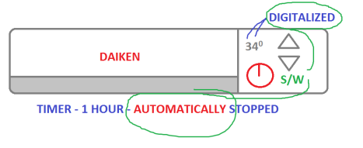Basically the software divided into 2 types.
1.System software
Eg. o.s , device drivers, translators
2.Application software
Eg: whatsapp, phonepe,…
What is a language?
Generally the languages like telugu, English, hindi etc are used to communicate with humans. Hence they are called human languages.
To communicate with machines we are using the computer programming languages like C / C++ / Java / .Net / py etc. i.e. they are used to write the
programs [ software ] to communicate with the machines.
Basically the computer languages divided into 3 types.
1.Machine language: Created with binary code. Eg: 10101110
2.Low level / assembly languages: Created with English like shortcuts called MNEMONICS. Eg: sub, add
Example:
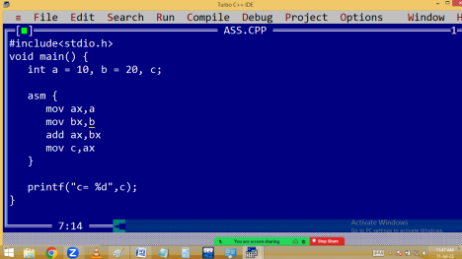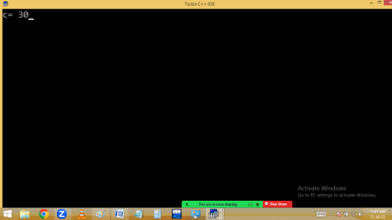3.High level languages: created with simple English.
Eg: subject, addition,..
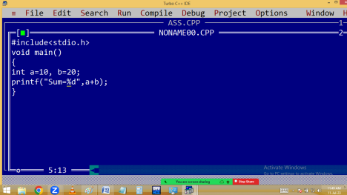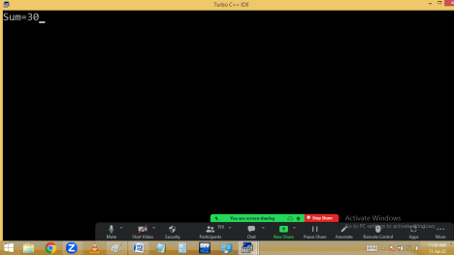C comes with both low level and high level features. Hence c is a middle level language.
Because of the middle level features, we can develop both system software [ low level features ] and application software [ high level features ]. Hence c is a multipurpose programming language.
What is a translator?
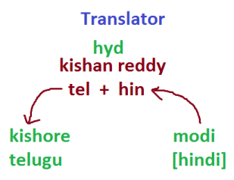
Always the user given instructions are in English, which is called source code or source program. But the computer understandable code is binary code / machine language. to convert this source code into binary code and
to check the errors we are using the translators like
1.Compiler
2.Interpreter
3.Assembler
Compiler and interpreter both used to convert high level programs to machine language.
Assembler is used to convert low level programs to machine language.
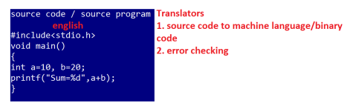Compiler shows the errors after completion of total source code. i.e. compiler completes the total source code at once by leaving error lines.
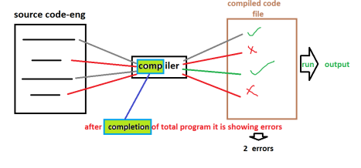Interpreter checks line by line. i.e. when any error is occurred, stop the process until that error is solved.
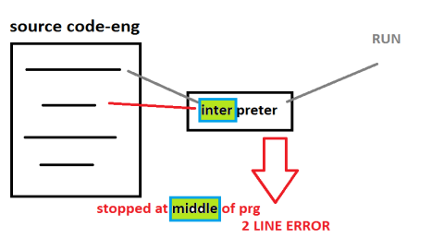Assembler working style is similar to compiler.
C & C++ are using compilers. Hence they are called compiler based programming languages. java / .net / py are using both compilers and interpreters. Hence they are called compiler based interpreted languages.
What is programming paradigm?
Every programming language is having particular structure with rules and regulations, which is technically called programming paradigm.
Before c language the programming languages are using monolithic programming.
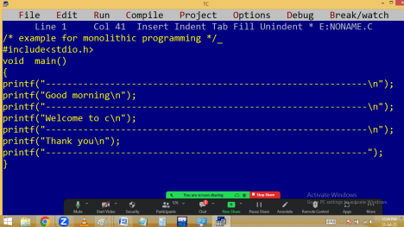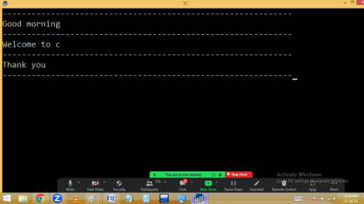In monolithic programming we are creating the entire program using single program. Due to this it
is very difficult to find the errors, takes more memory and performance is poor.
To avoid this program they have introduced procedure oriented programming. In pop a big program divided into several small sub program / sub routines / procedures / functions / modules / structures/. Hence c program is collections of procedures, it is called procedure oriented programming.
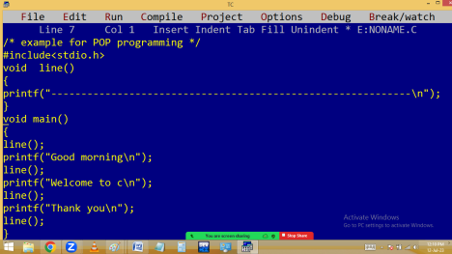
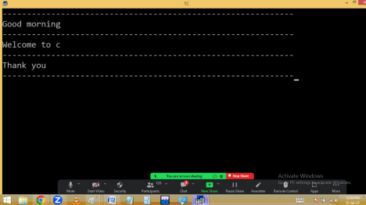Advantages:
1. Modularity: Dividing a big program into several small modules.
2.Reusability: Write once, use many times. 3.Simplicity: Easy to understand / read. 4.Efficiency: performance is high
Procedure oriented structure:
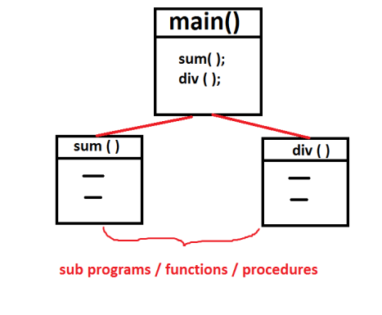
C follows – POP
C++ & Python – POP & OOP – Multi-Paradigm programming languages.
Java, .net – oop
Why c is a general purpose language?
Using C we can develop different type of software like
1.Operating systems
Eg: windows, unix, linux, android, mac, ios,… 2.Editors
Eg: Notepad, wordpad, Ms-word, Edit+,… 3.Translators
Eg: compiler, interpreter, assembler
4.Commercial applications
Hotel, super market, college software,…. 5.Data base software
Eg: oracle, my sql, sql server, mongodb, dbII, SQLite,..
6.Device drivers
Eg: audio / video / printer / usb drivers
7.Embedded applications
8.Media players
Eg: vlc , mx-player, windows media player,.. 9.Antivirus
Eg: avast, Norton, mcafee,….
10. Browsers
Eg: chrome, firefox, edge,….
11. Mobile and PC Games.
12. Any type of stand-alone app’s
Hence c is also called it is a multi-purpose programming language.

